**Day 3**

**Hot Spring NP to Driskill Mountain Trailhead, LA:** 180 miles, 3.75 hours

Get on AR-7 South for 26 miles or so

At Cadd Valley turn right to merge onto I-30 W Merge onto I-30 W go 30.9 mi

Take exit 46 for AR-19 toward Prescott 0.3 mi

Turn left onto AR-19 S 2.0 mi

Continue onto W Main St 0.4 mi

Turn right onto W 1st St S 0.4 mi

**Turn right onto US-371 S** 17.0 mi

Turn left onto US-278 E/US-371 S

Continue to follow US-371 S 17.9 mi

Turn left onto US-371 S/E McKissack Continue to follow US-371 S 7.1 mi

Turn left onto W North St 0.2 mi

Turn right onto N Jackson 1.9 mi

Turn right onto US-79 S **Entering Louisiana** 33.0 mi

Turn right onto US-79 BYP 1.3 mi

Turn left to stay on US-79 BYP Follow LA-9 S to US-80 E/2nd St in **Arcadia** 19 min (16.6 mi)

Just before Arcadia LA-9 will cross I-20.

Here are Summitpost Directions from I-20:  
  
- Take Exit 67 S for 1.7 miles to Arcadia  
- Go S on SR 147 for 7.4 miles  
- Turn SW (R) on SR 797 and continue for 3.7 miles  
- Turn W (R) onto SR 507 at T-intersection and continue for 1.0 miles to the Mt Zion Presbyterian Church parking lot

Directions given on theoutbound.com: From Interstate 20 take exit 69 for Arcadia, Louisiana. Turn left and drive south on state route 151. Continue on route 151 for 1.5 miles. Then turn left onto state route 147/Jonesboro Rd. Continue on Jonesboro Rd for 9.3 miles. Then turn right onto state route 507. Stay on this route for 2.7 miles until you reach the First Presbyterian Church on your right .There is also a black sign for Driskill Mountain. Park in the gravel parking lot near the cemetery. The trail head starts here. The trail is a very distinct red dirt trail. You will see two gates and two other blue blazed trails that veer off in different directions. Continue left at the first "Y" where there is currently a sign. After about 300 yards you will come to the second gate and a blue blazed trail veering off to the right. Don't follow that trail. Continue on the well marked trail and then stay right at the second "Y" in the trail as it veer upward to the top.

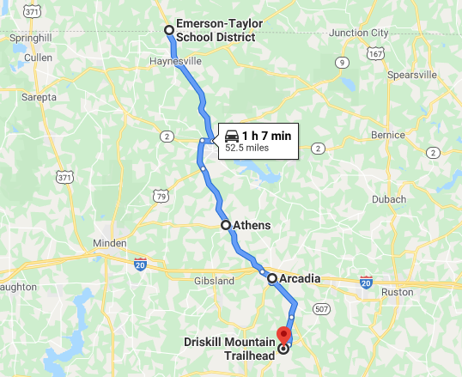

**About the Mountain**: Elevation 534 ft / 163 m. When most people think of Louisiana, mountains are the last thing to come to mind and with good reason. This state is one of 3 in the U.S. with its lowest point located below sea level, and its highest point is the 3rd lowest in the country; only Florida's Britton Hill and Delaware's Ebright Azimuth are lower than this 163m (535ft) bump known as Driskill Mountain. The area is very densely forested as is common in the Piney Woods of East Texas and Louisiana. The primary route on Driskill Mountain begins at the parking lot of the Mt. Zion Presbyterian Church, however, those desiring more vertical gain and more distance can park further south at the intersection where Jot Em Down Rd. comes in. There are two false summits near Driskill's true summit, so the landowners have taken significant steps to help prevent hikers from missing their goal. A large pile of rocks marks the high point.

Easy hike on nice, well marked trail. Less than 1 mile to and 1 mile back. Nice valley overlook nearby. Easy drive from I – 20 to get to trail head and parking. Very easy 1.8 mile round trip hike to check off another state high point. The route is very easy to find and not too step. There was not much of a view at the overlook due to tree growth. Overall it was not a bad way to spend 45 minutes. Located in the wooded non-swampy parts of LA with lots of agriculture, cross roads, small towns, churches makes it interesting to try to imagine what state you are in.

**Camping**: The town of Arcadia has a Days Inn. 131 miles away on I-20 is the Homochitto NF. Similarly 207 miles (3+ hours) east on I-20 is the Bienville NF.

Bienvile NF is about 35-45 miles from Jackson Mississippi and I-20 cuts it in half. Jackson is 170 miles from Arcadia.

If you can’t find primitive camping there is the Marathon Campground in the Bienvile NF

Marathon Campground Directions Head east on I-20 E, and take exit 80 for MS-481 toward Morton/Raleigh and Pulaski - 0.3 mi

Turn right onto MS-481 S (signs for Raleigh) 3.2 mi

Turn left onto Morton-Marathon Rd 6.4 mi

Turn left onto MS-35 N 23 ft

Turn right onto Morton-Marathon Rd7.4 mi

Continue onto Smith Co Rd 506 1.5 mi

Turn right onto Shopping Center Rd 520